SC-OS-02 - Osako Installation Instructions
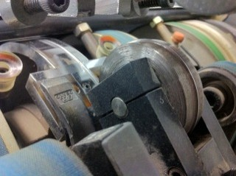
Groove ‘A’.
The black rubber creasing matrix is to be applied into the groove by using the 2 sided adhesive.

Remove the original male metal creasing disc and replace with the Tech-ni-Fold 2-channelled female component.

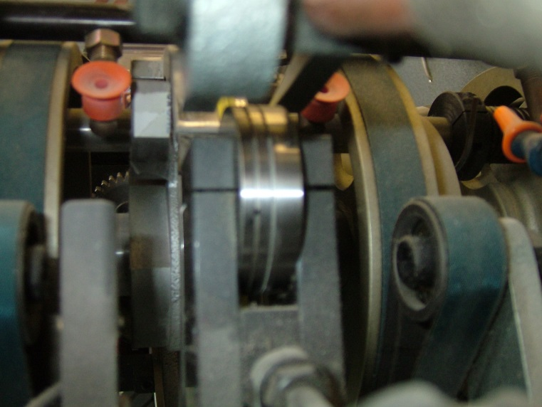
Align the female into the centre of the drum Groove ‘A’.
This is achieved by loosening the screws at the bottom of the assembly and pushing the female into position and retightening. Use the horseshoe shaped collars ‘B’ to hold and fix the creasing assembly in position once female is centralised.
Use the supplied shim washers to reduce any side-ways movement of the female component that may be present. Place them either-side of the female component (ensuring female remains centralised).

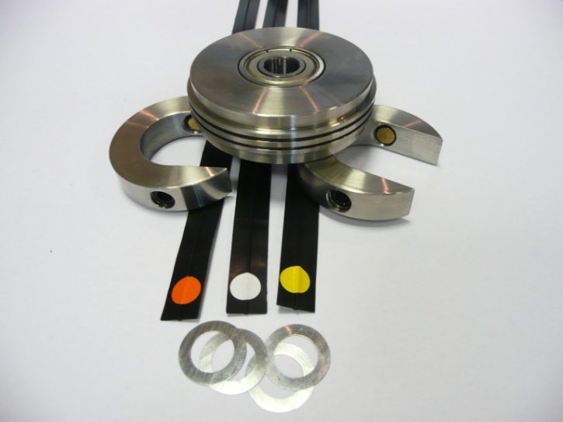
Horseshoe holding collars ‘B’; the 3 black colour-coded rubber creasing matrix and the shim washers.

Installing Horse-Shoe Shaped Collars ‘B’
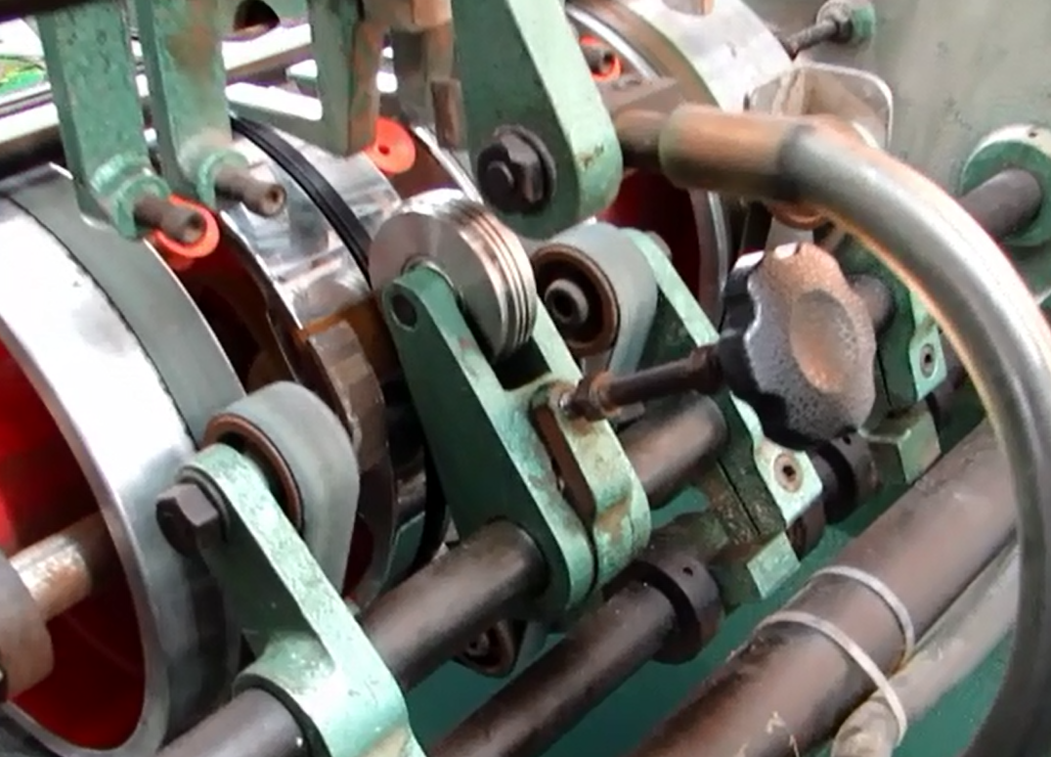

The Horse-Shoe shaped collars are installed on to this holding shaft. One collar either-side of the creasing assembly.

Choosing Which Creasing Matrix To Use
The 3 black rubber creasing matrix are suitable for different paper thicknesses.
As a guide...
Light paper = Orange matrix
Medium paper = White matrix
Heavy paper = Yellow matrix
Underneath all black rubber matrix there is a ‘V’-shaped protrusion – this fits into the Groove ‘A’. The coloured dot on the matrix is the side that performs the creasing.

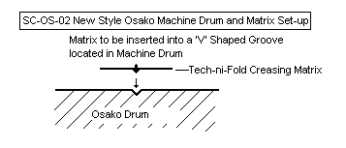

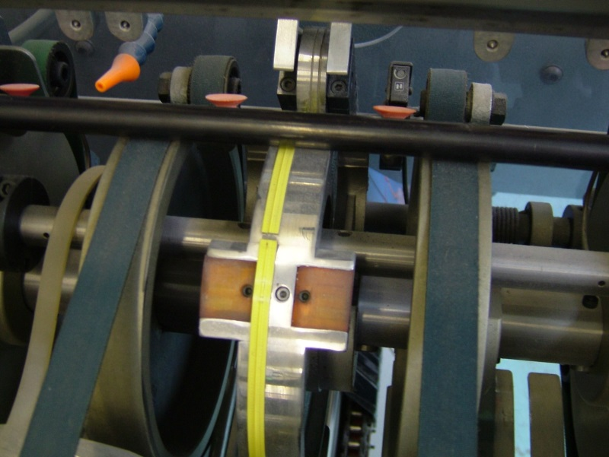
Applying The Creasing Matrix

The yellow strip indicates where the black creasing matrix is positioned.
Please note: when applying the creasing matrix the starting point is in the centre as shown with arrow.
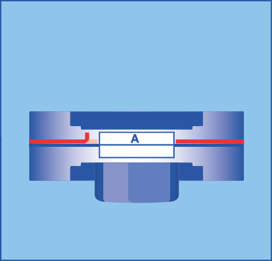
The 2-sided adhesive is placed at each side of the drum Groove ‘A’. Apply a full length around the circumference of the drum as close to the Groove ‘A’ as possible. Repeat the application on the other side of Groove ‘A’.
IMPORTANT: Do not peel away the 2-sided adhesive backing fully yet.
On both sides of the Groove ‘A’, fold over just a small area of backing of the applied tape. See image.
Do this on the front and back application of the tapes.

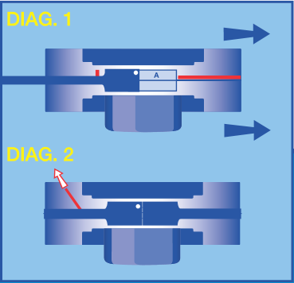
Align one end of the chosen colour-coded creasing matrix and press firmly into position.
Begin stretching the creasing matrix, pushing the ‘V’-shaped underside into the scoring groove whilst a second person manually turns the drum in a forward motion [diagram 1].
When the drum cycle is complete push the end of the creasing matrix firmly onto an exposed area of adhesive strip so that the two ends of the creasing matrix are bonded to the machine drum (the two ends of the creasing matrix do not have to be touching).
Now gently pull away the full two lengths of adhesive backing without disturbing the creasing matrix above. [see diagram 2].
IMPORTANT: Ensure creasing matrix is centrally positioned in required female channel.

